**Stress-Induced Alcohol Consumption and WCST Performance in College Students**

***Jack Doggett, Shari Nudelman, Sarah Murphy***

**Abstract**

It’s no secret that college campuses are crawling with chronic alcohol users. Universities are demanding academically and require high cognitive functioning on a daily basis, inducing high levels of stress. Research has shown that high-stress exposure correlates to an increase in alcohol consumption for college-aged students. Additionally, previous studies have revealed that the majority of college students report being severely stressed and using alcohol as a coping mechanism. Investigating the effects of stress-induced chronic alcohol usage on cognitive functioning is important for the prevention and reversal of the potentially harmful effects in the college population. The Wisconsin Card Sorting Task (WCST) is a familiar paradigm in psychology, most commonly used to assess cognitive flexibility, executive functioning, and problem-solving skills. The current study’s focus is on how alcohol consumption in response to stress and as a coping mechanism affects performance on the WCST in UMD college students. The WCST was used to assess cognitive functioning in two groups: those who used alcohol as stress-coping and those who didn’t. A survey was sent to the participant population to assess alcohol usage. The respondents were then split into the control and experimental groups and given the WCST. Pre and post-task stress levels were assessed via *the perceived stress scale.* It was hypothesized that those who utilize alcohol as a stress-response coping mechanism will exhibit poorer WCST performance due to task-inducing stress. Specifically, poorer response time and higher error rates combined with less performance gain during the tail of trial blocks would show a higher increase in self-reported stress levels in the alcohol-coping groups. Results show that alcohol-coping participants had a slower response time than control participants and had a higher incidence of stress levels increasing during and after the WCST from pre-test levels compared to control participants.

**Methods**

**Participants**

Data was collected from eight college-aged students from the University of Maryland. Of the eight participants, four were categorized as the alcohol-positive group while the other four were in the limited alcohol use group based on the results of the recruitment survey. All four partcipants completed the task outside the lab and were currently not enrolled in the course, had never taken it before, and had no prior experience with the WCST.

**Materials**

A recruitment survey was created and administered using Google Forms software. The survey consisted of six yes or no and open-ended questions about lifestyle choices regarding alcohol consumption. The link to the survey was posted in various digital discussion forums including UMD Reddit. Based on the responses to the survey questions, two groups were formed consisting of six participants in each group. If participants answered “Yes” to using alcohol to cope with stress as well as using alcohol to cope with stress 2-5 or 5-7 days a week, they were assigned to the alcohol-positive group. If partcipants answered “No” to using alcohol to cope with stress as well as consuming 0-2 or 0-5 drinks per week on average, they were assigned to the no alcohol group. However, partcipants in this group must have answered “0” when asked how many days per week they use alcohol to cope with stress to qualify for the no-alcohol group. Once the two groups were formed, a PsyToolkit survey link to the WCST task was emailed to them. For confidentiality reasons, each chosen participant was also assigned and emailed a random code. Experimental results are tied back to the Google Form results with this code instead of their personal details to ensure anonymity.

The Wisconsin Card Sorting Task was created and administered using PsyToolKit software. The PsyToolkit code zip file for the task was downloaded from the experiment library. The number of trials was changed from 60 to 200 to foster higher statistical power and increase the reliability of the data. Additionally, the audible feedback sound on correct trials was removed and only present on incorrect trials to emphasize errors. The WCST was then created and embedded into a survey using PsyToolKit to be administered during the study. A modified version of the Perceived Stress Scale was included both at the beginning of the survey and once the WCST was completed. It consisted of questions regarding their stress levels before, during, and after the task in addition to their stress levels in general. The survey was then saved, compiled, and emailed to the eight chosen participants.

**Procedure**

The PsyToolKit provided URL for the survey was emailed to the eight chosen participants. Included in the email was a subject-specific randomized survey code to be entered into the survey at the start of the task for confidentiality. At the start of the survey, participants were prompted with a brief informed consent, instructions on how to perform the task, and questions regarding their stress level. The objective of the task is to match a card to one of the four cards on the screen based on the rule. The rules include classifying the cards according to color, shape, or number. Participants are expected to figure out the rule based on trial and error or inference and then proceed with the rule for the following trials. However, the rule changes every 10 trials to measure adaption to changing rules. Once the rule changes, participants are expected to go through the same mental processes to try and figure out the new rule and proceed with it until the rule changes again. When a participant matches the card incorrectly, an error sound will play to notify of a mistake. After all 200 trials were completed, each participant was then asked to answer the questions regarding their current stress levels at the end of the test and their stress levels during the test. Data collected through PsyToolKit for all twelve participants was uploaded to Excel for further analysis. Data for each participant was sorted in Excel to reflect response time, accuracy, and errors. Three types of errors were assessed: if the trial was an error, if the trial was a preservation error, and if the trial was not a preservation error. A score of 0 indicated no and a score of 1 indicated yes.

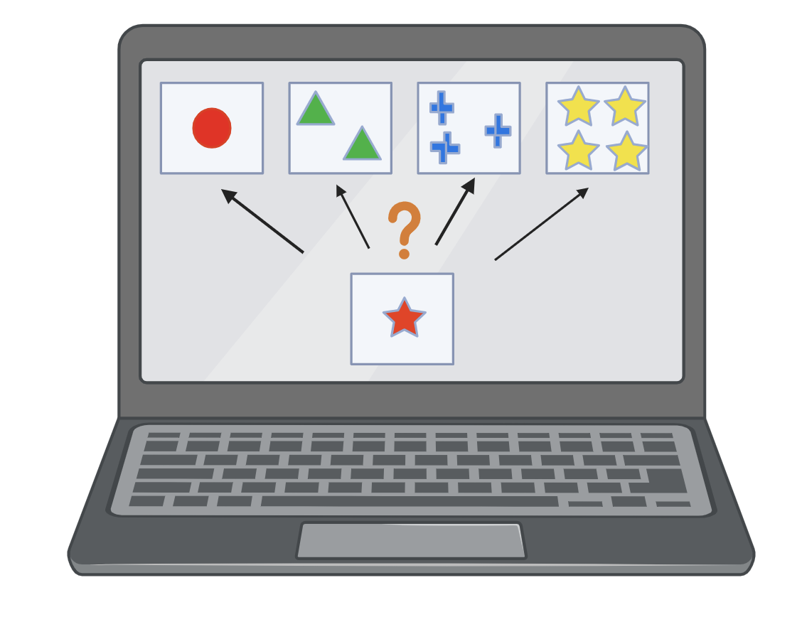

***Figure A: Visual Representation of the Wisconsin Card Sorting Task.***

**Figures and Results**

We had an experimental and control group, each with four participants. Each participant was asked to measure their stress from 1 to 10 before taking the Wisconsin Sorting Task. The WCST had 20 trial blocks where a new rule match would happen, each trial block had 10 trials for a total of 200 trials per participant. After completing the WCST, we asked each participant to measure their stress during the WCST and after the WCST from 1 to 10. We measured the response time and perseveration and non-perseveration error rate for the WCST for each trial, as well as grouping trials that are the first five in a trial block and last five in a trial block.

We compared the response time, perseveration error rate, and non-perseveration error rate between the experimental and control groups. We not only looked at the individual level in each group, such as if they increase in performance during the second half of trials, but also compare the average between the two groups. If the inability to cope with stress affects how participants in the experimental group perform in the WCST, we should expect a longer response time, and more perseveration and non-perseveration error rate (they make more mistakes and take longer to make decisions on which card to choose during each trial). During trial blocks, we test to see if each group of participants increases in performance in the second half of trial blocks by comparing their response time and error rate to their performance in the first half of trial blocks. From previous studies, it has been found that when the first half of trial blocks introduces a new sorting match participants have higher stress, while stress lowers in the second half of trial block when WCST participants have learned and can easily match cards; and participants perform better during the second half of trial blocks (Chowdhury & Doggett, 2023). The experimental group is affected by stress, in that they need alcohol to cope with it. Will the experimental group be able to withstand the stress of the WCST and perform as well as the control group despite the inability to access alcohol?

We looked at how individual participants responded during the WCST. Each participant had 20 trial blocks, consisting of 10 trials per block. We compare the response time, perseverative error rate, and non-perseverate error rate for the first five trials (half) of and final five trials of trial blocks per participant.

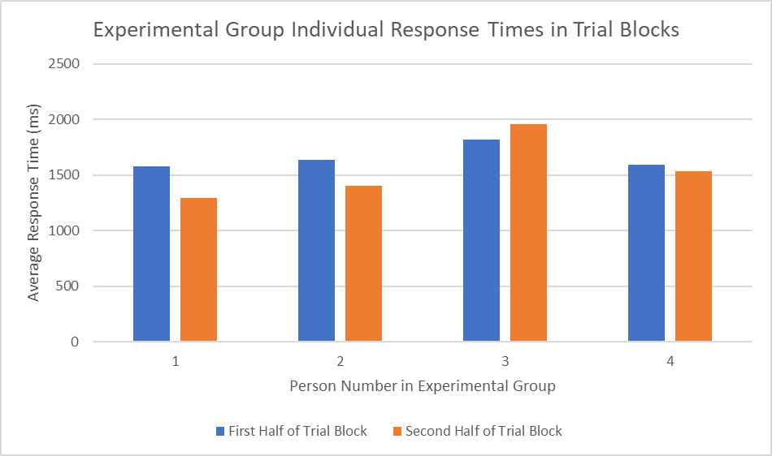

***Figure B: Response Time by Trial Block Halves for Experimental Group***

*Figure B* shows that only 2 of the 4 participants in the experimental group see a noticeable decrease in response time in the second half of trial blocks. Participant 1 of the experimental group went from an average response time of 1574ms in the first half of trial blocks to 1293ms in the second half of trial blocks. Using a two-sided t-test to compare two means, we receive a p-value of 0.004 that the two response times per half of the trial block are the same. Thus we conclude that participant 1 statistically decreased in response time from the first half to the second half of trial blocks. For participant 2, they went from 1634ms to 1403ms, which leads to a p-value of 0.10 assuming they are equal. This is not statistically significant, so we will assume participant 2 did not change in response time from either half of the trial blocks. For participant 3, they went from 1819ms to 1956ms, which is an increase in response time! However, this change is not significant with a p-value of 0.56, so we again can not conclude that there was a significant statistical difference in response time. For participant 4, they went from 1467ms to 1317ms, with a p-value of 0.22. Once again, we fail to conclude that the response time has changed. Of the four participants in the experiment group, only one participant statistically changes (and in their case decreases) their response time from the first half to the second half of trial blocks. This suggests that the experimental group fails to see a performance increase in response time during the second half of trial blocks in the WCST, where an increase in performance is expected.

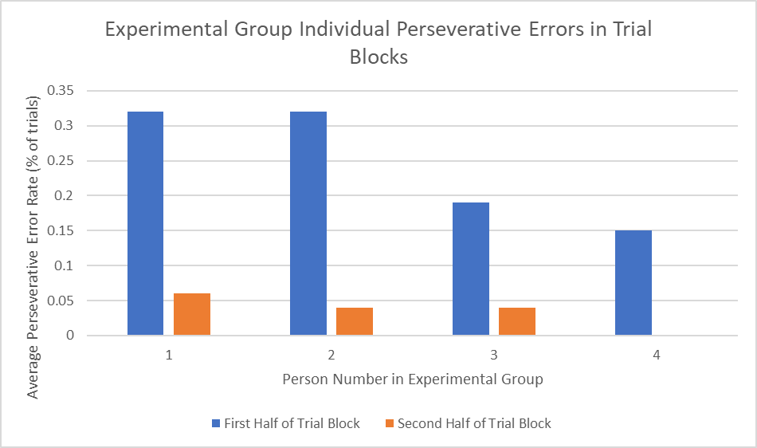

***Figure C: Perseverative Error Rate by Trial Block Halves for Experimental Group***

*Figure C* shows the change in perseverative errors in each half of the trial blocks for participants in the experimental group. As expected during the WCST, participants learn the new sorting rule during a new trial block and match with the new rule set, this leads to a reduced number of perseverative errors in the second half of the trial block. All participants in the experimental group successfully show learning the new matching rule in each trial block. For participant 1, they go from a perseverative error rate in the first half of trial blocks of 0.32 to 0.06 in the second half. For participant 2, they go from 0.32 to 0.04. For participant 3, they go from 0.19 to 0.04. For participant 4, they go from 0.15 to 0. Comparing their perseverative rates for the first half and second half of trial blocks for equality, all receive a p-value of 0.000 when testing for equal proportions with a Z-test. Thus we conclude that the experimental group shows a decrease in perseverative errors from each half of the trial blocks. This is expected with all participants in the WCST as they learn the new match rule.

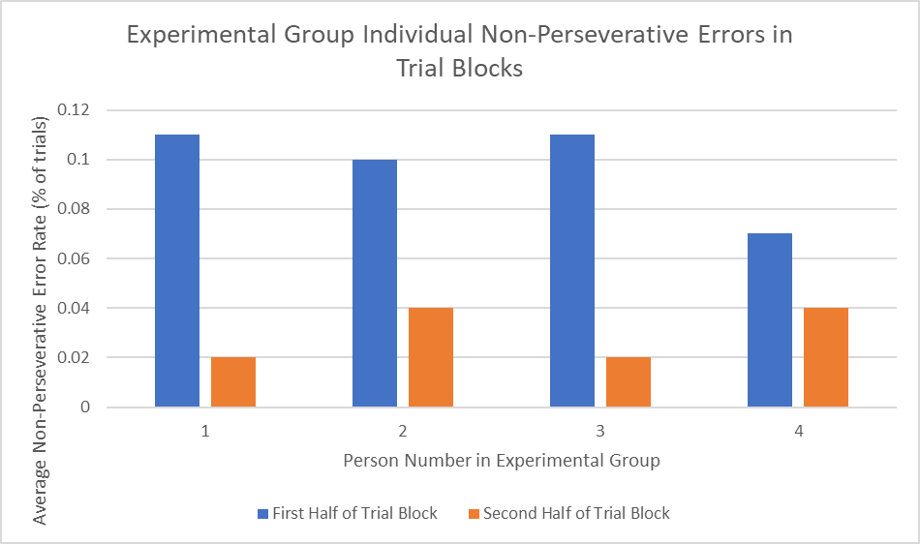

***Figure D: Non-Perseverative Error Rate by Trial Block Halves for Experimental Group***

*Figure D* shows the change in non-perseverative errors in each half of trial blocks for participants in the experimental group. The rate of non-perseverative errors in each half of trial blocks is expected to decrease as participants no longer randomly guess to get the next matching rule, though there may be non-perseverative errors further in the trial block due to participant error. All participants in the experimental group show a lower non-perseverative error during the second trial block, except participant 4 is not statistically different. For participant 1, they go from a non-perseverative error rate in the first half of trial blocks of 0.11 to 0.02 in the second half. For participant 2, they go from 0.10 to 0.04. For participant 3, they go from 0.11 to 0.02. For participant 4, they go from 0.07 to 0.04. Comparing their perseverative rates for the first half and second half of trial blocks for equality with a z-test for proportions, participant 1 received a p-value of 0.009, participant 2 receives a p-value of 0.09, participant 3 has a p-value of 0.009, and participant 4 has a p-value of 0.35. Three out of the four participants in the experimental group saw a significant decrease in their non-preservative error rates, while all saw a decrease going to the second half of trial blocks in the WCST. Thus we conclude that non-perseverative errors decreased in the second half of trial blocks for the experimental group.

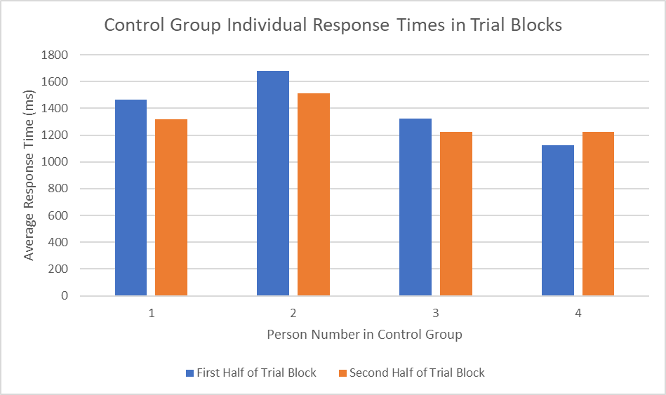

***Figure E: Response Time by Trial Block Halves for Control Group***

*Figure E* shows that 3 of the 4 participants in the control group see a noticeable decrease in response time in the second half of trial blocks. Participant 1 of the control group went from an average response time of 1467ms in the first half of trial blocks to 1317ms in the second half of trial blocks. Using a two-sided t-test to compare two means, we receive a p-value of 0.22 that the two response times per half of the trial block are the same. For participant 2, they went from 1679ms to 1512ms, which leads to a p-value of 0.35 assuming they are equal. For participant 3, they went from 1324ms to 1222ms, this change has a p-value of 0.41. For participant 4, they went from 1123ms to 1225ms, with a p-value of 0.05. Of the four participants in the control group, only one participant statistically changes (and in their case increases) their response time from the first half to second half of trial blocks. However, the other three participants decrease their response time (though not statistically). This suggests that the control group fails to see a performance increase in response time during the second half of trial blocks in the WCST, where an increase in performance is expected, although it may just be data inconclusiveness from poor variance.

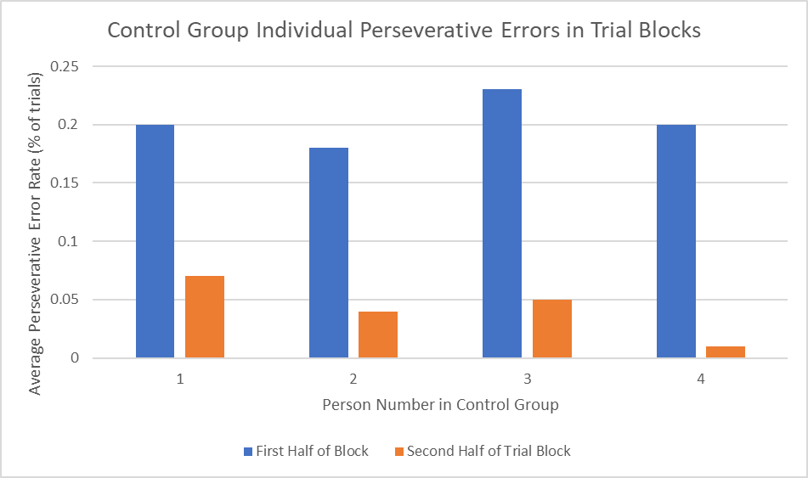

***Figure F: Perseverative Error Rate by Trial Block Halves for Control Group***

*Figure F* shows the change in perseverative errors in each half of trial blocks for participants in the control group. As expected during the WCST, participants learn the new sorting rule during a new trial block and match with the new rule set, this leads to a reduced number of perseverative errors in the second half of the trial block. All participants in the control group successfully show learning the new matching rule in each trial block. For participant 1, they go from a perseverative error rate in the first half of trial blocks of 0.2 to 0.07 in the second half. For participant 2, they go from 0.18 to 0.04. For participant 3, they go from 0.23 to 0.05. For participant 4, they go from 0.2 to 0.01. Comparing their perseverative rates for the first half and second half of trial blocks for equality, all receive a p-value of 0.00 when testing for equal proportions with a Z-test. Thus we conclude that the control group shows a decrease in perseverative errors from each half of the trial blocks. This is expected with all participants in the WCST as they learn the new match rule.

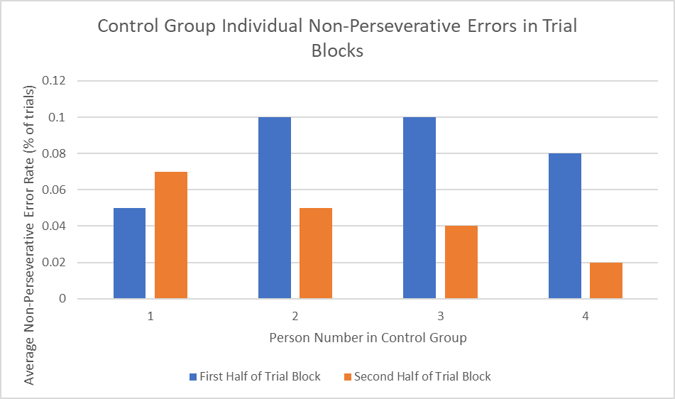

***Figure G: Non-Perseverative Error Rate by Trial Block Halves for Control Group***

*Figure G* shows the change in non-perseverative errors in each half of trial blocks for participants in the control group. The rate of non-perseverative errors in each half of trial blocks is expected to decrease as participants no longer randomly guess to get the next matching rule, though there may be non-perseverative errors further in the trial block due to participant error. All participants in the control group show a lower non-perseverative error during the second trial block, except participant 1 who saw increases in non-perseverative error rate. For participant 1, they go from a non-perseverative error rate in the first half of trial blocks of 0.05 to 0.07 in the second half. For participant 2, they go from 0.10 to 0.05. For participant 3, they go from 0.1 to 0.04. For participant 4, they go from 0.08 to 0.04. Comparing their perseverative rates for the first half and second half of trial blocks for equality with a z-test for proportions, participant 1 received a p-value of 0.55, participant 2 receives a p-value of 0.17, participant 3 has a p-value of 0.09, and participant 4 has a p-value of 0.05. Two out of the four participants in the control group saw a significant decrease in their non-preservative error rates, while another saw an insignificant decrease and the first participant saw an insignificant increase in non-preservative error rate going to the second half of trial blocks in the WCST. Thus we conclude that non-perseverative errors decreased in the second half of trial blocks for the control group.

We now compared the statistics of the entire experimental and control group, using distributions gathered from all 800 trials in each group. We looked at the individual-level comparisons of performance on the WCST, now we look at differences between the average of the groups.

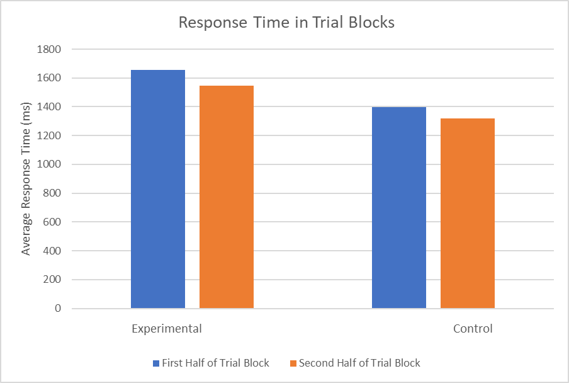

***Figure H: Response Times between Experimental and Control Group in Trial Block Halves***

In *Figure H* we see the average response time of trials in the experimental and control group, both during the first and second half of trial blocks in the WCST. Two patterns are visible. First, during the second half of trial blocks both the experimental and control blocks have a lower average response time. Second, that the control block has a lower average response time than the experimental group. For all trials, the experimental group has an average response time of 1600ms while the control group has an average response time of 1359ms. Comparing the two with a two-sided t-test for equals means gives a p-value of 0.000. The experimental group has an average response time of 1654ms during the first half of trial blocks, the control has an average response time of 1398ms during the first half of trial blocks. Comparing the two for equality gives a p-value of 0.000. The experimental group has an average response time of 1546ms during the second trial block, the control an average response time of 1319ms during the second trial block. Comparing the two gives a p-value of 0.004. Thus we conclude that the control group has a faster response time than the experimental group. We compare if the response time changes in the group during each trial block. Comparing the average response time between the first and second half of trial blocks within the experimental group, we get a p-value of 0.20. For the control group comparing the average response time of its first and second half of the trial block for equality, we get a p-value of 0.22. Although both decrease during the second half of the trial block, it isn’t statistically significant. Perhaps more participants would be needed. It is clear though, that the control group has a faster response time than the experimental group.

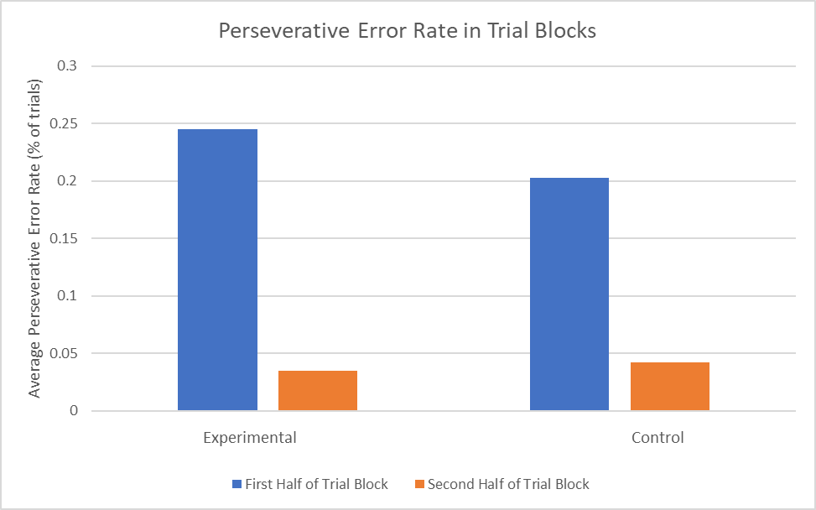

***Figure I: Perseverative Error Rate between Experimental and Control Group in Trial Block Halves***

In *Figure I* we see the perseverative error rate of trials in the experimental and control group, both during the first and second half of trial blocks in the WCST. Two patterns are visible. First, during the second half of trial blocks both the experimental and control blocks have a lower average perseverative error rate. Second, the control block has a lower perseverate error than the experimental group in the first half of trial blocks. For all trials, the experimental group has a perseverative error rate of 0.14 while the control group has a perseverative error rate of 0.1225. Comparing the two proportions with a z-test gives a p-value of 0.29. The experimental group has a perseverative error rate of 0.245 during the first half of trial blocks, the control has a perseverative error rate of 0.2025 during the first half of trial blocks. Comparing the two for equality gives a p-value of 0.14. The experimental group has a perseverative error rate of 0.035 during the second trial block, the control a perseverative error rate of 0.0425 during the second trial block. Comparing the two gives a p-value of 0.58. Thus we conclude that the control group has a similar perseverative error rate as the experimental group, except in the first trial block where there is a slight decrease. We compare if the perseverative error rate changes in groups during each trial block. Comparing the perseverative error rate between the first and second half of trial blocks within the experimental group, we get a p-value of 0.000. For the control group comparing the perseverative error rate of its first and second half of the trial block for equality, we get a p-value of 0.000. Thus we conclude that both groups statistically decrease their perseverative error rate in the second trial block, which is expected, and don’t differ that much between each other, except in the first trial block where there is a slight decrease.

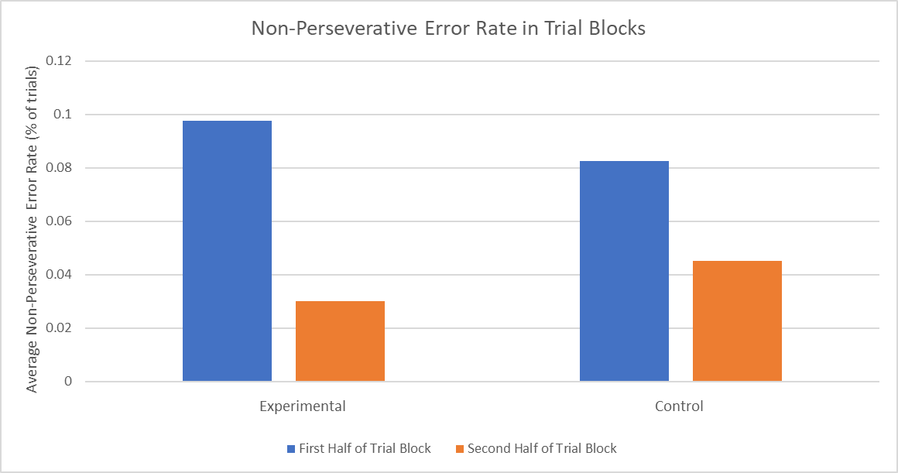

***Figure J: Non-Perseverative Error Rate between Experimental and Control Group in Trial Block Halves***

In *Figure J* we see the non-perseverative error rate of trials in the experimental and control group, both during the first and second half of trial blocks in the WCST. Two patterns are visible. First, during the second half of trial blocks both the experimental and control blocks have a lower non-perseverative error rate. Second, the control block has a lower non-perseverate error than the experimental group in the first half of trial blocks. For all trials, the experimental group has a non-perseverative error rate of 0.06375 while the control group has a non-perseverative error rate of 0.06375. Comparing the two proportions with a z-test gives a p-value of 1.00. The experimental group has a non-perseverative error rate of 0.0975 during the first half of trial blocks, the control has a non-perseverative error rate of 0.0825 during the first half of trial blocks. Comparing the two for equality gives a p-value of 0.45. The experimental group has a non-perseverative error rate of 0.03 during the second trial block, the control a non-perseverative error rate of 0.045 during the second trial block. Comparing the two gives a p-value of 0.26. Thus we conclude that the control group has a similar non-perseverative error rate as the experimental group, except in the first trial block where there is a slight decrease. We compare if the perseverative error rate changes in groups during each trial block. Comparing the non-perseverative error rate between the first and second half of trial blocks within the experimental group, we get a p-value of 0.000. For the control group comparing the non-perseverative error rate of its first and half second half of the trial block for equality, we get a p-value of 0.029. Thus we conclude that both groups statistically decrease their non-perseverative error rate in the second trial block, which is expected, and don’t differ that much between each other, except in the first trial block where there is a slight decrease.

Performance data on the WCST showed some differences and similarities between the experimental and control groups. Most significantly, the control group has a faster response time. Both groups show expected decreases in error rate from the first and second trial block, but during the first trial block the control group has a slightly lower error rate than the experimental group. Individually this is seen as well. Both have similar changes at the participant level in response times during the first and second half of trial blocks. What does this mean overall then? The control group is faster than the experimental group, and in the beginning of trial blocks, has a slightly lower perseverative and non-perseverative error rate. This suggests that the WCST impacts the ability of individuals who use alcohol to cope with stress. Performance in response time is worse overall and during the more stressful part of trial blocks, there is a larger error rate.

We now looked at the stress levels of participants during the experiment. We measure the difference in self-reported stress levels from before and during the WCST, and before and after the WCST. If the WCST causes higher stress in the experimental group, we will see a larger increase in stress.

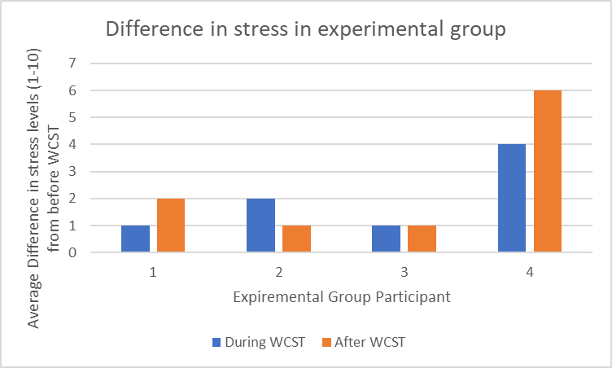

***Figure K: Difference in stress levels in experimental group***

*Figure K* shows the differences in stress levels for participants in the experimental group from taking the WCST. For participant 1, they increase 1 stress level from before and during the WCST task, and increase 2 stress levels from before and after the WCST task. For participant 2, they increase 2 stress levels from before and during the WCST task, and increase 1 stress level from before and after the WCST task. For participant 3, they increase 1 stress level from before and during the WCST task, and increase 1 stress level from before and after the WCST task. For participant 4, they increase 4 stress levels from before and during the WCST task, and increase 6 stress levels from before and after the WCST task. It is important to note that all four participants have increased stress during and after the WCST.

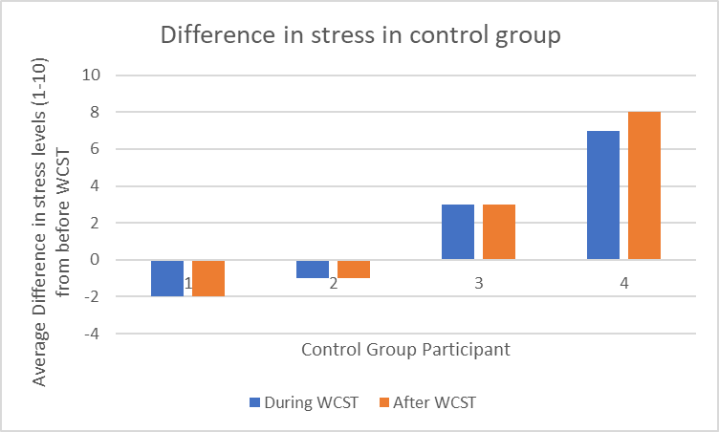

***Figure L: Difference in stress levels in control group***

*Figure L* shows the differences in stress levels for participants in the control group from taking the WCST. For participant 1, they decrease 2 stress levels from before and during the WCST task, and decrease 2 stress levels from before and after the WCST task. For participant 2, they decrease 1 stress level from before and during the WCST task, and decrease 1 stress level from before and after the WCST task. For participant 3, they increase 3 stress levels from before and during the WCST task, and increase 3 stress levels from before and after the WCST task. For participant 4, they increase 7 stress levels from before and during the WCST task, and increase 8 stress levels from before and after the WCST task. What is important to note is that only two participants increase stress levels in the control group, the other two decrease stress levels.

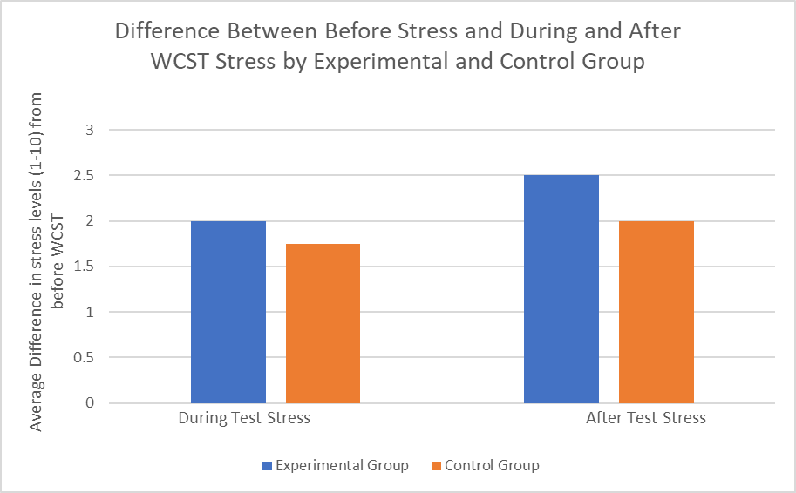

***Figure M: Average Difference in stress levels in experimental control group***

*Figure M* shows the average difference in stress levels from before and during the WCST and before and after the WCST for the experimental and control groups. For the experimental group, the average stress increase from before the WCST and during the WCST is 4.5 stress levels, for the control group it is 5.75 stress levels. Comparing the two average differences with a two-sided t-test for equality of means gives a p-value of 0.45. For the experimental group, the average stress increase from before the WCST and after the WCST is 6.5 stress levels, for the control group it is 7.5 stress levels. Comparing the two average differences with a two-sided t-test for equality of means gives a p-value of 0.85. Thus we conclude that on average the two groups increase in stress level statistically similarly. However, as seen in *Figure L* participant 4 of the control group heavily skews the average.

We found that the control group has less stress increase from the WCST than the experimental group as fewer participants saw an increase in stress. This would imply that the WCST causes more stress to the experimental group, suggesting that individuals who use alcohol for coping are more stressed by a difficult task than the general public.

**Discussion**

The current study investigated the relationship between alcohol consumption as a stress-coping mechanism and cognitive functioning using the Wisconsin Card Sorting Task (WCST). The WCST is a common psychological tool used to assess cognitive flexibility and executive functioning like error prediction and working memory. The sample population was college students at UMD. Previous research suggests a connection between high stress, alcohol use, and academic pressure on college campuses. The hypothesis posited that individuals using alcohol to cope with stress would exhibit poorer performance on the WCST, particularly in terms of a higher number of preservative errors, reflecting the potential negative impact of alcohol on neurological function as a central nervous system depressant.

The analysis focused on response time, perseveration error rate, and non-perseveration error rate. The expectation was that stress would lead to longer response times and increased error rates in the experimental group. Additionally, the study examined whether both groups showed improved performance in the second half of trial blocks, as seen in previous studies where stress decreases as participants learn the task. For the experimental group, Figure B displayed response times in trial block halves. Two out of four participants showed a noticeable decrease in response time in the second half. Participant 1 demonstrated a statistically significant decrease, while Participant 2 did not. Participants 3 and 4 did not exhibit significant changes. Overall, the experimental group failed to show the expected performance increase in response time during the second half of trial blocks. Figure C presented perseverative error rates for the experimental group. All participants successfully learned the new matching rule in each trial block, leading to a decrease in perseverative errors in the second half. Statistical tests confirmed significant reductions in perseverative error rates for all participants. In summary, the experimental group did not demonstrate the anticipated improvement in response time during the WCST, suggesting that the stress induced by the unavailability of alcohol negatively affected their performance in accordance with our hypothesis. However, they did exhibit successful learning, though slower, of the new matching rule, as indicated by reduced perseverative errors.

The results mentioned above can be interpreted in different ways. The first is that the students who use alcohol to cope with stress have a barrier to making executive decisions in a timely manner. The slower response times and more perseverative errors in the first half of the trial blocks in comparison to the control group indicate poorer performance on the WCST. They take more trials to figure out the rule change. Because alcohol consumption lowers inhibition, which makes decision-making more difficult, more preservative errors and slower response time for the experimental group aligns with our hypotheses. Alcohol also hinders regions of the brain concerned with memory, supporting the given results. Furthermore, the students who engage in stress-induced alcohol consumption reported higher stress levels during and after the WCST from pre-test levels in comparison to the control group. This suggests that students who use alcohol as a coping mechanism become more stressed more easily by a difficult task than students who do not. Alcohol usage under a chronic duration has been proven to increase cortisol levels in the body. Cortisol is a hormone produced by the adrenal glands that induces the body’s stress response. Having higher levels of cortisol leave an individual more prone to quicker and more intense stress response.

Given the findings, there are a multitude of directions for further research to support the findings. The first avenue of research could be conducting neuroimaging studies, such as functional magnetic resonance imaging (fMRI) or electroencephalography (EEG), to observe the neural activity in the brains of participants during the WCST. This could help identify specific brain regions affected by alcohol consumption and stress, providing a neurobiological basis for the observed behaviors. There are also previous studies that have hypothesized what regions of the brain are impacted by alcohol, and these neuroimaging studies can help to pinpoint pre and post task brain responses. The next avenue could be to design experiments specifically targeting memory functions to assess the impact of alcohol on memory. We saw that memory was hindered in our experiment, and previous research has shown for alcohol to impact memory as well. This could involve tasks like memorization, recall, or recognition tests to quantify the extent to which alcohol hinders memory-related cognitive functions. Because stress responses directly correlated with cortisol levels, an experiment could be designed to monitor cortisol levels in participants before, during, and after engaging in stressful cognitive tasks. This longitudinal study could help establish a direct link between alcohol consumption, stress levels, and cortisol production. Comparisons with a control group that does not consume alcohol would strengthen the findings. Decision making was also impacted as found by the current study. Utilizing decision-making tasks similar to the WCST via Psyctoolkit could help to assess the performance of both experimental and control groups to understand how alcohol-induced stress affects decision-making across different cognitive fields. At a more complex level, intervention studies could be designed to reduce stress mid-experiment or compare alcohol-dependent coping groups versus those who use healthy methods to cope with stress. These intervention studies could also be formatted by having controlled alcohol administration to a group who consumes alcohol but not in high quantities or for stress-coping. This could help to evaluate the effects of alcohol, stress, and cognitive functioning from a neutral starting point rather than just black-and-white comparison groups. By combining these experimental approaches, researchers can strengthen the validity and reliability of the findings, contributing to a more comprehensive understanding of the relationship between stress, alcohol consumption, and cognitive performance.

As mentioned in the previous sections, much research has already been done in the field of alcohol and executive functioning. A study by Gullot et al aimed to investigate the effects of different alcohol doses on cognitive performance, focusing on tasks related to executive functions (EF), such as the Wisconsin Card Sorting Test (WCST). This study specifically wanted to investigate the functioning of the frontal lobe and possible impairment. The researchers hypothesized that high and medium alcohol doses would impair performance on the WCST, as was found in the present study done. In accordance with these findings, on the WCST, participants with high and medium alcohol doses showed greater perseverative errors compared to the placebo group, indicating difficulties in set-shifting. The total errors were increased only in the high alcohol dose group. However, there were no differences in non perseverative errors and categories achieved between the groups. This aligns with a meta-analysis suggesting that perseverative errors may be a more sensitive measure of frontal lobe dysfunction. The study suggested that the adverse effects on WCST performance, particularly in terms of perseverative errors, are likely due to dysfunction in the dorsolateral prefrontal cortex induced by alcohol intoxication. The study concluded that moderately high doses of alcohol impair set-shifting, as evidenced by increased perseverative errors in the WCST.

The second article by Maharjan et al discusses the neurological effects of chronic alcohol consumption with a focus on assessing brain regions that have been found to be involved with alcohol and/or executive functioning. It mentions that areas like the prefrontal cortex, thalamus, hippocampus, and amygdala are affected, leading to cognitive deficits, impaired executive functions (EF), and structural changes observed through neuroimaging studies. The mesocorticolimbic pathways were observed, specifically the subcortical (the ventral striatum, thalamus, hippocampus, and amygdala) and cortical (the ventromedial and posterior dorsomedial frontal cortex) regions. The results of this analysis revealed a consistent pattern of grey matter loss in patients. Additionally, this pathway was hypothesized to be barricaded and impaired via alcohol, potentially causing the development and maintenance of addiction via negative reinforcement. This inference was based on fMRI evidence for its role in adaptive behavioral learning. The primary nodes of the dorsal anterior cingulate cortex (dACC) and insular cortex also showed grey matter atrophy. All of these findings contribute to the idea that the cognitive and behavioral changes seen in chronic alcohol users may represent functional imbalances within a cortico-striato-thalamo-cortical regulatory loop supporting executive control and self-regulation accords with this evidence of extensive brain damage. The impact on emotional facial expression processing, impaired psychomotor speed, working memory, and attention is shown via a meta-analysis of neuropsychological test results such as the WCST, Iowa Gambling Task, and Go-NOGO. The results posit a correlation between alcohol use, reward networks, and executive networks. This correlation was also shown in impacting addiction severity and abstinence capacity. The article also mentions alcohol-related brain damage (ARBD) which was defined as a spectrum encompassing various neurocognitive impairments such as neuroinflammation and glutamate toxicity.

In conclusion, the study investigated the impact of alcohol consumption as a stress-coping mechanism on cognitive functioning, specifically using the Wisconsin Card Sorting Task (WCST) in college students. The experimental group, using alcohol for stress coping, showed no expected improvement in WCST response time but exhibited successful learning of the new rule, suggesting that alcohol-induced stress negatively affects executive decision-making. Slower response times and more perseverative errors in the experimental group, along with reported higher stress levels, support the hypothesis that alcohol hampers cognitive performance, possibly through inhibition and memory-related brain regions. Recommendations for future research include neuroimaging studies, memory-focused experiments, cortisol level monitoring, and decision-making tasks to comprehensively understand the relationship between stress, alcohol, and cognitive performance.

***Author Contributions***

Sarah Murphy→ Abstract, Methods, Discussion

Jack Doggett→ Figures and Results, Abstract, data collection

Shari Nudelman→ Discussion and Abstract

***References***

Chowdhury, Z., & Doggett, J. (2023). Adaptation to Feedback in the Wisconsin Card Sorting Task. PSYC 407 Class, University of Maryland.

Guillot, C. R., Fanning, J. R., Bullock, J. S., McCloskey, M. S., & Berman, M. E. (2010). Effects of alcohol on tests of executive functioning in men and women: a dose response examination. *Experimental and clinical psychopharmacology*, *18*(5), 409–417. https://doi.org/10.1037/a0021053

Maharjan, S., Amjad, Z., Abaza, A., Vasavada, A. M., Sadhu, A., Valencia, C., Fatima, H., Nwankwo, I., Anam, M., & Mohammed, L. (2022). Executive Dysfunction in Patients With Alcohol Use Disorder: A Systematic Review. *Cureus*, *14*(9), e29207. https://doi.org/10.7759/cureus.29207